# “Implementation of Wireless Sensor System for Soil NPK analysis using Cubic Spline Method”

## BTech Major Project Report

SUBMITTED BY

Mangesh Gund [B194048]

Arjun Yachwand [B194032]

PrashantWalunj [B194158]

Chaitanya Barsawade [B198040]

GUIDED BY

Prof. Santosh Warpe

SCHOOL OF COMPUTER ENGINEERING AND TECHNOLOGY



ALANDI (D), PUNE-412105, MAHARASHTRA (INDIA)DEC. 2019

# Implementation of Wireless Sensor System for Soil NPK analysis using Cubic Spline Method

## A Major Project Progress- I Report

*Submitted in partial fulfilment of the requirements for the award of the degree*

*of*

Bachelor of Technology

*in*

**SCHOOL OF COMPUTER ENGINEERING AND TECHNOLOGY**

BY

Mangesh Gund

Arjun Yachwad

Prashant Walunj

Chaitanya Barsawade

**SCHOOL OF COMPUTER ENGINEERING AND TECHNOLOGY**



ALANDI (D),PUNE-412105, MAHARASHTRA (INDIA)

MAY, 2020



## CERTIFICATE

# This is hereby certified that the work which is being presented in the BTech. Major Project Progress- I Report entitled “Implementation of Wireless Sensor System for Soil NPK analysis using Cubic Spline Method”, in partial fulfillment of the requirements for the award of the Bachelor of Technology in Information Technology Engineering and submitted to the SCHOOL OF COMPUTER ENGINEERING AND TECHNOLOGY of MIT Academy of Engineering, Alandi (D), Pune is an authentic record of work carried out during a period from August 2019 to December 2019 under the supervision of Dr. Avinash Bhute , School of Computer Engineering and Technology.

Mangesh Gund PRNNo.0120160 Exam Seat No.B194048

Arjun Yachwad PRNNo.0120160 Exam Seat No.B194032

Prashant Walunj PRNNo.0120160 Exam Seat No.B194158

Chaitanya Barsawade PRNNo.0120160417 Exam Seat No.B198040

Date: 18 Dec. 2019

Seal of school

Dean,

School of Computer Engineering and Technology,

MIT Academy of Engineering, Alandi (D), Pune

Date: 18 Dec. 2019

*Signature of External examiner/s Signature of External examiner/s*

*Name: Name:*



## CERTIFICATE

The matter presented in this major project report has not been submitted by us for the award of any other degree elsewhere.

*Signature of Candidates*

*(Mangesh Gund)*

*(Arjun Yachwad)*

*(Prashant Walunj)*

*(Chaitanya Barsawade)*

This is to certify that the above statement made by the candidates is correct to the best of my knowledge.

**Date: 18 Dec. 2019** *Signature of project Advisor*

*(Prof. Santosh Warpe)*

**Index**

|  |  |  |  |
| --- | --- | --- | --- |
| **Sr.No** | **Content** | | **Page No.** |
| **1** | **Introduction** | | **2** |
| **2** | **Literature Survey** | | **3-6** |
| **3** | **Theory and relevance** | | **7** |
| **4** | **Project Analysis** | | **7** |
| **5** | **Methodology** | | 8-9 |
| **6** | **Proposed Requirement Specification** | | 10 |
| **7** | **Proposed Project Design** | | 10 |
| 7.1 | **Use case Diagram** | 10 |
| 7.2 | **Activity Diagram** | 11 |
| 7.3 | **Sequence Diagram** | 11 |
| 7.4 | **Class Diagram** | 12 |
| 7.5 | **Component Diagram** | 12 |
| **8** | **Proposed Project Planning** | | 13 |
| **9** | **Work Description** | | 14 |
| 10 | **Conclusion** | | 15 |
| 11 | **References** | | 16 |

**Introduction**

As agriculture plays a major part for economic development of India, so we need to adapt new technologies for Precision Agriculture. Soil is a complex medium that contains minerals, organic matter, micro-organisms, air and water. Over-fertilization results in groundwater pollution or toxic accumulation of chemicals in the soil. The aim of this experiment is to adjust fertilization based on crop needs and soil properties and to reduce the amount of fertilizer in soil without diminishing yield.

The productivity ratio of farm cultivation in India is relatively lesser than other countries. The low productivity results in inadequate supply of food to overall population of India. To improve productivity and profit margin, adaptation of new technologies can help us at great extent.As there are 2 types of fertilizers Primary and Secondary, in primary nitrogen, phosphorus, potassium are there and in secondary calcium, magnesium, sulfur. Types are divided based on need of fertilizer to crop. We propose the system with Wireless Sensor Net- work for Nitrogen (N), Phosphorus(P), Potassium(K) monitor in using sensor nodes. This system present study and analysis of Wireless Sensor Network that applied in agriculture for automated farming. This can help the end users like farmers for the better understanding of agriculture practices to be adopted for distribution of fertilizers.

**Literature Survey**

**Review 1: -**

**Title and Author: -** Victor Grimblatt, Guillaume Ferre, Francois Rivet, Christophe Jego, Nicolas Vergara “Precision agriculture for small to medium size farmers - An IoT approach”, 2019.

Improving the soil yield with IoT is a new way to feed this population growth. Their proposed solution integrates IoT to monitor precisely agriculture. The subsequent manufacture of a SoC will demonstrate on site how farmers can be helped to improve soil yield.

**Review 2:-**

**Title and Author** : Marianah Masrie*, Ahmad Zahid Mohd Rosli, Rosidah Sam, Zuriati Janin and Mohd Khairi Nordin, “Integrated optical sensor for NPK Nutrient of Soil detection”  8-30 November 2018.

The developed integrated optical sensor was able to detect the NPK nutrients in soils. The light for LED at 470 nm, 950 nm and 660 nm emitted at 1 kHz modulation frequency was successfully received by detection system within 15 mm optical path length. The optical transmittance of each LED light through the transparent container is high, approximately at 80 %. Based on the testing results, there was a significant interaction between the light and NPK samples taken from different location that made the light intensity reduced as the voltages were dropped. The output responses for high NPK were found at 32.0 volts for Nitrogen, 4.6 V for Phosphorus and 19.8 V for Potassium.

**Review 3:-**

**Title and Author: -** A.Izuddin Zainal Abidin1, Faizal Ahmad Fadzil2, Yen “Micro-controller Based Fertilizer Dispenser Control System”, 2018.

This study provides a significant impact especially to farmers as it offers an easy and efficient way to automate the fertilizer spreading process. The functionality of the system provides a user-friendly platform for users to monitor their soil condition and fertilization process. All research activities including literature review, qualitative interview, system design, prototype development and testing are interrelated and are conducted with the aim to achieve research objectives.

**Review 4: -**

**Title and Author: -** Jay Prakash Kumar, Shailesh Deshpande, Arun Inamda “Detection Of Fertilizer Quantity In Soil Using Hyperspectral Data”, 2018

In this paper, they have developed a quantification equation between the diagnostic depths and the fertilizer concentration in soil. It would be challenging task to verify whether the developed equations remain valid for low to very low concentrations of fertilizers. They plan to extend these experiments with more number of soil samples and a few additional fertilizers. Hyperspectral detection of agrochemicals provides an opportunity to develop innovative methods in this regard. The present study reports efforts taken in the same direction. They focus on fertilizer application and attempt to analyze the spectral signature of soil and fertilizer mixture.

**Review 5:-**

**Title and Author:-** Arpit Rawankar, Mayurkumar Nanda, Hemant Jadhav, Prem Lotekar, Rahul Pawar, ”Detection of N,P,K Fertilizers in Agricultural Soil with NIR Laser Absorption Technique”, 9-11 February, 2018

Photon absorption technique is a simple and non-destructive analytical method that can be used to quantify several soil properties simultaneously. The main challenge for the evaluation of soil properties is to find suitable data pre-treatment and calibration strategies. In this study, a tunable laser is used to find reflectance and absorption photon data and values for soil properties.

**Review 6: -**

**Title and Author:-** Kamal Kumar Ghanshala,Rahul Chauhan,R.C Joshi, “A Novel Framework for Smart Crop Monitoring Using Internet of Things (IOT)” 2018.

Traditional agricultural trends followed in India, this system mainly focussed on the soil nutrients and its adequate utilization. Earlier most of the crop monitoring techniques were based on temperature and humidity and limited to user end only but proposed system is based on soil nutrients and based on IOT. Cloud computing make it globally accessible for data analytics.

**Review 7:**

**Title and Author:** Miguel Carmo1,3, Roberto García-Ruiz2, Maria Isabel Ferreira1 & Tiago Domingos3,”The N-P-K soil nutrient balance of Portuguese cropland in the 1950s:

The transition from organic to chemical fertilization”, 14 August 2017

The early 1950s balances together with the evolution of chemical fertilization consumption provide a snap-shot of the inflection from an agriculture fertilized predominantly through recycled N in biomass to one where chemical N prevailed. Chemical K and P supply was also growing (though not as much as N), but K fertilization remained mostly organic whereas chemical P predominance had already been set in previous periods. The adaptation of arable crops towards a larger integration of legumes would have improved availability. Additionally, several cities were adapting their waste and sewage systems to produce organic fertilizers during the 1950s.

**Review 8:-**

**Title and Author:** Siti Subaedah, A.Aladin,and Nirwana, Fertilization of Ni- trogen, Phosphor and Application of Green Manure of Crotalaria juncea In Increasing Yield of Maize In Marginal Dry Land,Agriculture and Agricultural Science Procedia, 9:20-25, 2016.

This paper seems to focus on fertilization of N, P and application of Crotalatria juncea green manure improve growth and increase the yield of maize in marginal dry land. The experiment was carried out at the dry land of South Sulawesi Province, which is a better place to carry out this experiment. Maize also known as corn. The land used in the experiment was divided into three blocks. Each block was divided into 2 main plots. This type of arrangements helps to carry out this experiment successfully.

**Review 9:-**

**Title and Author:** Agni Biswas, Sarthak Prakash”, Farming Technology for India Agriculture Based Sensorics and Indicative Systems”,2015.

Sometimes climate changes, farmers suicides,rapid urbanization etc. Rapid technological advances and timely policy interventions have not only helped avert a food crisis in India but has also ensured a steady rise in food production and productivity.More effective tools need to be invented to ease the farmers struggle for survival and at the same time optimize the production from the soil.

**Review 10:-**

**Title and Author:-** R.Sindhuja,B.Krithiga,”Soil Nutrient Identification Using Arduino”, 2018

Due to complex soil pretreatment and chemical analysis,standard testing time for NPK is time consuming. Using an automatic electrochemical sensor system for continuous nutrient determination.Electrochemical sensor rapidly responds to targeted ions in minutes, suitable for in-field rapid detection.Time is the critical factor for soil nutrient detection since the variability of soil nutrient levels may be quite high over time.

**Theory and Relevance**

In the field of precision agriculture and organic farming, it is important to continuously monitor the fields as they are site specific. NPK fertilizer is a complex fertilizer comprised primarily of the three primary nutrients required for healthy plant growth. The agriculture industry relies heavily on the use of NPK fertilizer to meet global food supply and ensure healthy crops. We obtained that value from rapitest sensor. Also we use WSN that can communicate the information gathered from a monitored field through wireless links. For wireless communication, Zigbee technology is used to collect data which is then transferred to the server and get the final value using Cubic spline method.

Cubic spline method is our main basic value conversion algorithm we are using in project.Cubic spline method is 3rd degree polynomial equation, which gives more accuracy in result after compare with standard value of NPK. Its only about cubic spline, we use interpolation theory which give relevance of checking value between two points on curve in mathematical manner. Interpolation main purpose is to give accurate value between two slave nodes as we are using nodes for detecting value(brief introduction of node is in module description point.)

**Project Analysis**

In this project we have to detect NPK value of each crop using WSN to give optimum fertilizers to given crop. WSN is often a technology used within an IoT system. A large collection of sensors, Wireless Sensor Network (WSN) is the technology, in which the data collected from the field of interest is transmitted through wireless link. WSN can be used in various fields such as monitoring, wireless measurements, controlling, etc.

Finally, obtained values of NPK then comparing to the standard values as per crops, required NPK value given to the farmer on our software.As we expect very accurate value from our output of project which helps farmer for using NPK fertilizer’.

**Methodologies**

In the mathematical field of numerical analysis, interpolation is a method of constructing new data points within the range of a discrete set of known data points. To map the physical parameter readings for areas in farm where taking manual readings is not possible.We use Spline Interpolation instead of Newton Backward and Forward Interpolation, Langrages method and Runge-Kutta method. Its (Splines) advantage is higher accuracy with less computational effort. It is a computationally efficient method and the produced algorithm can easily be implemented on a computer. E.g. If we have a reading at 1 point and then directly at 2nd point 25 meters away. Then we shall interpolate the values for points at every meter between the two measured points.

1. **Interpolation:**

Interpolation is a method of constructing new data points within the range of a discrete set of known data points. In engineering and science, one often has a number of data points, obtained by sampling or experimentation, which represent the values of a function for a limited number of values of the independent variable. It is often required to interpolate, i.e., estimate the value of that function for an intermediate value of the independent variable.

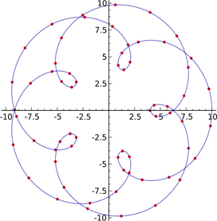

2. **Cubic Spline Interpolation: -**

Remember that linear interpolation uses a linear function for each of intervals [xk, xk+1]. Spline interpolation uses low-degree polynomials in each of the intervals, and chooses the polynomial pieces such that they fit smoothly together. The resulting function is called a spline. Spline interpolation uses low-degree polynomials in each of the intervals, and chooses the polynomial pieces such that they smoothly together. The resulting function is called a spline. For instance, the natural cubic spline is piecewise cubic and twice continuously differentiable. Furthermore, its second derivative is zero at the end points. The natural cubic spline interpolating the points in the table above is given by In this case we get f (2.5)=0.5972. Like polynomial interpolation, spline interpolation in cursa smaller error than linear interpolation and the interpolant is smoother.

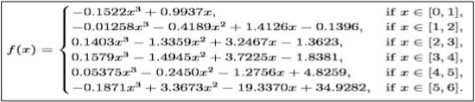

Cubic spline interpolation is a special case for Spline interpolation that is used very often to avoid the problem of Runge's phenomenon. This method gives an interpolating polynomial that is smoother and has smaller error than some other interpolating polynomials such as Lagrange polynomial and Newton polynomial.

q(x)=(1-t(x))y1 + t(x)y2 +t(x) (1-t(x)) ((1-t(x))a+ t(x)b

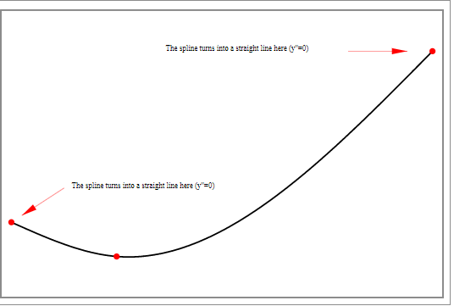

**Proposed Requirements Specification: -**

1. NET BEAN  V 8.2
2. Windows 8,10
3. Linux
4. NPK Sensor Rapitest
5. Arduino Uno
6. Wireless Sensor Network

**Proposed Project Design: -**

1. **Use case diagram: -**

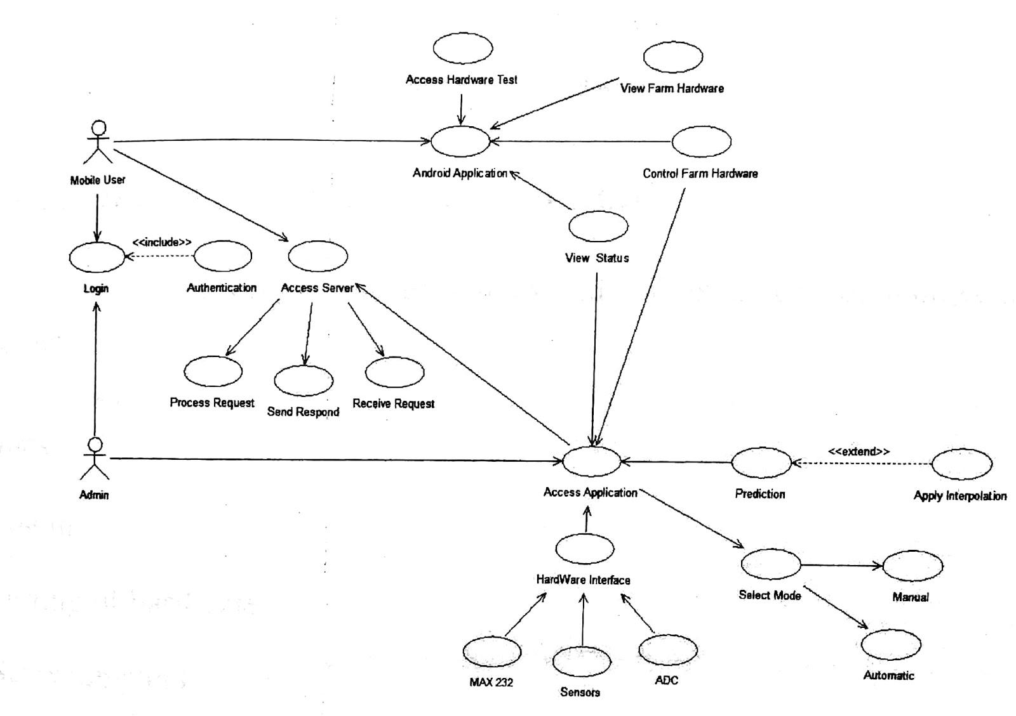

1. **Activity Digram: -**

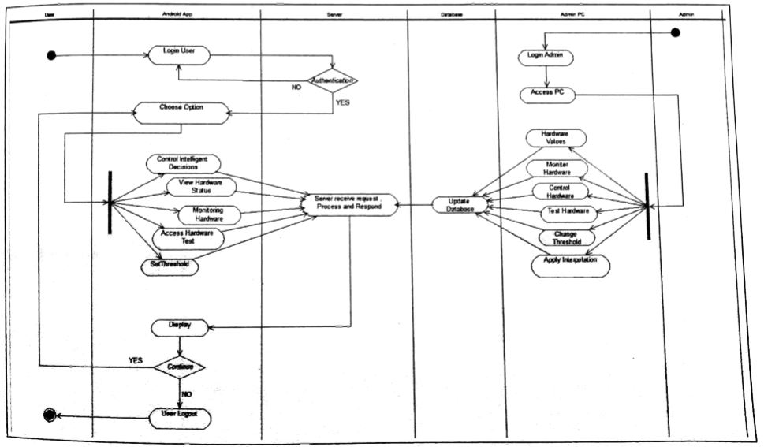

1. **Sequence Diagram: -**

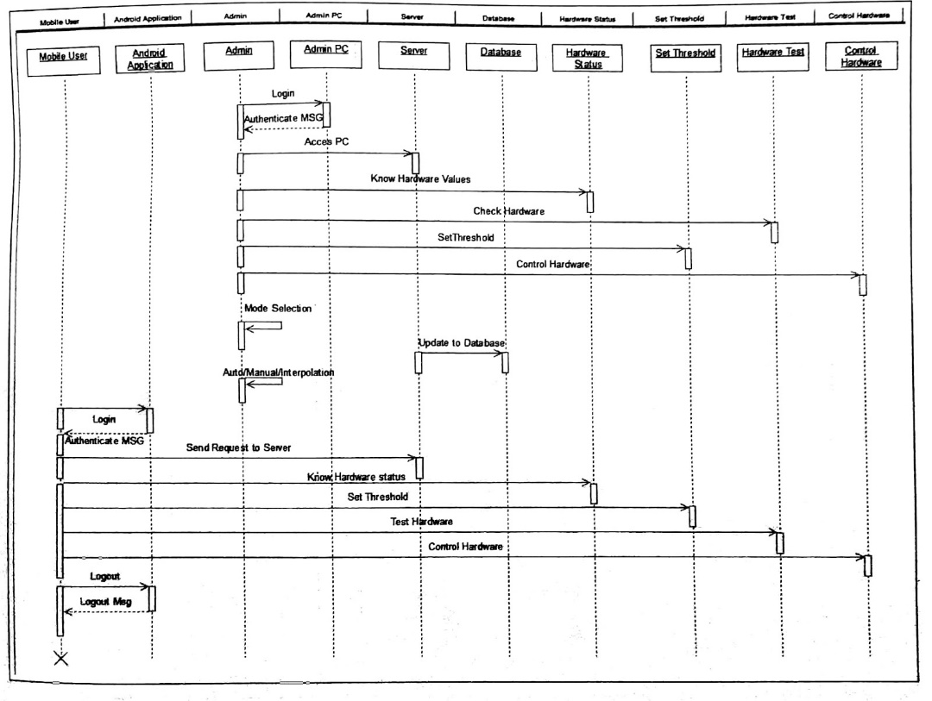

1. **Class Diagram: -**

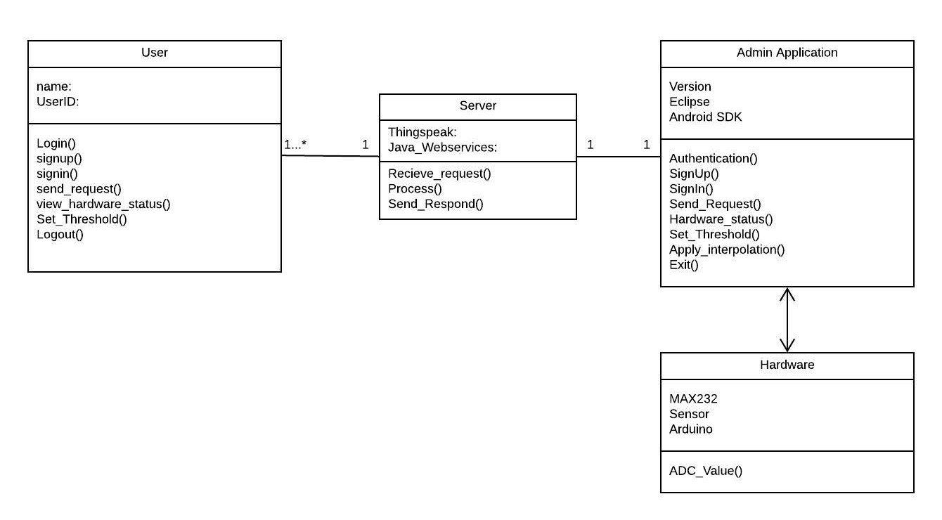

**5. Component Diagram:-**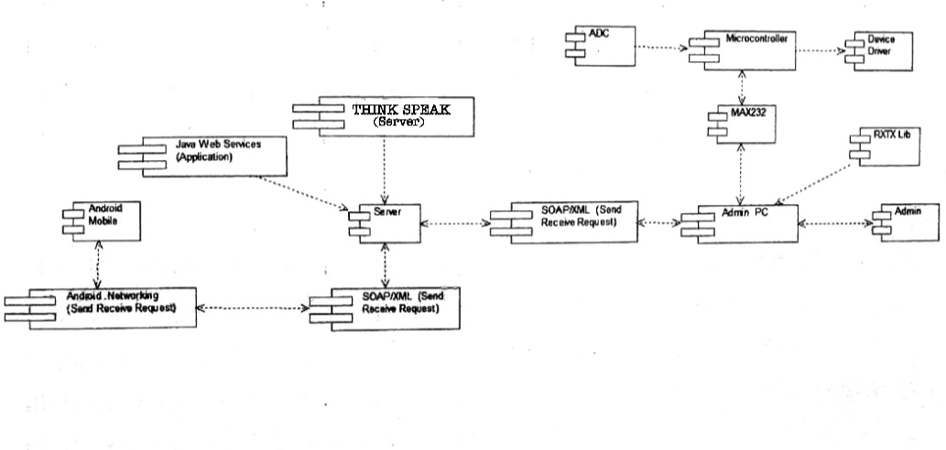

**Project Proposed Planning: -**

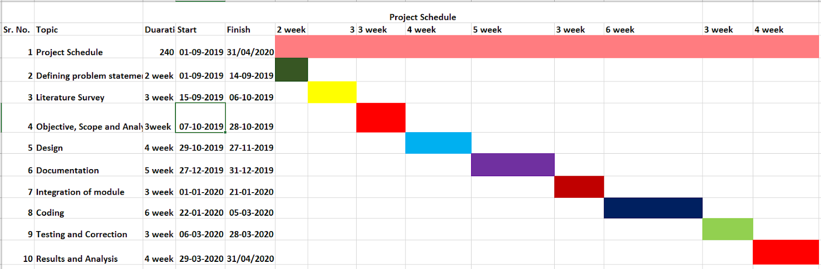

**Work/Module Description:-**

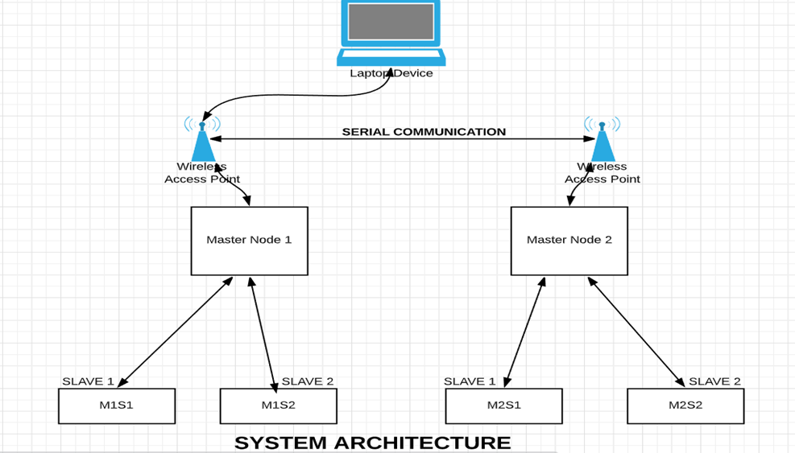

It represents architecture diagram of the project.from above figure how system work as per single module? is demonstrate.We are taking sensor values from sensor1,sensor2,...sensorn. The sensor values that we have taken are in analog form for future computations we need digital values,so that we are using ADC to convert analog values to digital form. ADC uses 10  bit register for calculating sensor unit acquires data from ADC and forward it to base-station through micro- controller. Micro-controller used in automatically control products and devices such as automobile engine system,remote controls,power tools, micro-controllers, are constructed to govern operators of embedded system. micro controllers consist of CPU,RAM,ROM. micro controller works on TTL protocol and our base-station unit works on binary values ,so for transmission between micro-controller and base-station we are using MAX-232. MAX-232 works on serial communication. Zigbee are flexible, they send and receive data over serial port which means they are compatible with both computer and micro-controller. Through zigbee, the data is transferred to base station and web server. Data stored on web server can be accessed through an android application which can remotely access the crop field conditions.

Above represents the architecture diagram of the project.In this we are using two master node, four slave node and one base station. we divide two slaves nodes for one master node and another two slave nodes for another master node. we connect two slave nodes labeled as M1S1 and M1S2 to one master node labeled as M1 and we connect to the two slave nodes labeled as M2S1 and M2S2 to another master node labeled as M2.

M1S1 and M1S2 slave nodes send data to master node M1. M2S1 and M2S2 slave nodes send data to master node M2.In this proposed system we used WSN is for collecting the sensed data, storing or processing the sensed data and transmitting data to the appropriate central station.

**Conclusion: -**

We have studied a lot of literature survey to get the knowledge about every keyword involved in the project. We have studied such as WSN, Rapitest, Spline Interpolation method langrage’s, newton backward and forward method and we conclude that spline advantage is higher accuracy with less computational effort. It is a computationally efficient method and the produced algorithm can easily be implemented on a computer.

**Reference: -**

1. Arpit Rawankar ; Mayurkumar Nanda ; Hemant Jadhav ; Prem Lotekar ; Rahul Pawar ; Libin Sibichan ; Akshay Pangare. Real-Time Monitoring of Soil Nutrient Analysis using WSN.Detection of N, P, K fertilizers in agricultural soil with NIR laser absorption technique. 3rd International Conference on Microwave and Photonics (ICMAP) Year: 2018
2. Victor Grimblatt, Guillaume Ferre, Francois Rivet, Christophe Jego, Nicolas Vergara “Precision agriculture for small to medium size farmers - An IoT approach”,(IEEE) Year: 2019.
3. Koppisetti Giridhar, C. Anbuananth, N. Krishnaraj,”Research on Various Routing Techniques in Wireless Ad-hoc Networks”(IEEE), Year: 2019.
4. Marianah Masrie*, Ahmad Zahid Mohd Rosli, Rosidah Sam, Zuriati Janin and Mohd Khairi Nordin, “Integrated optical sensor for NPK Nutrient of Soil detection”  8-30 November 2018.
5. R.Sindhuja,B.Krithiga,”Soil Nutrient Identification Using Arduino”,(AJAST),Year:2018
6. G. Sahitya; N. Balaji; C. D Naidu; S. Abinaya. Designing a Wireless Sensor Network for Precision Agriculture Using Zigbee, IEEE 7th International Advance Computing Conference (IACC) Year: 2017
7. Shylaja S.N. Dr.Veena M.B. Real-Time Monitoring of Soil Nutrient Analysis using WSN.(IEEE) Year:2017
8. G. Deepika; P. Ra- japirian. Wireless sensor network in precision agriculture survey. International Conference on Emerging Trends in Engineering,

Technology and Science (ICETETS) Year: 2016.

1. Agni Biswas, Sarthak Prakash, “Farming Technology for India Agricuture Based Sensorics and Indicative Systems”,(IEEE), Year: 2015.
2. Yusuf Abdullahi Badamasi, Abuja, Nigeria,”The Working Principle Of An Arduino”,(IEEE), Year: 2014.